COAT OF ARMS OF
THE MOODIES OF MELSETTER
EXPLAINED BY JAN MOODIE

Let's start by asking: what is a coat of arms?
In medieval times a coat of arms or coat-armour was just that: a coat worn over a warrior's armour. As time passed, the term started being used to describe the unique heraldic design on a shield or escutcheon or on a surcoat or tabard used to cover and protect armour and to identify the wearer. In heraldry, an escutcheon is a shield which forms the main element of the coat of arms. A surcoat was an outer garment commonly worn in the Middle Ages and a tabbard was a short coat, sleeveless or with short sleeves or shoulder pieces, also commonly worn by men in the Middle Ages.
The original use of a coat of arms was on the battlefield, so that knights in full armour could be distinguished from one another and from the enemy. Later on, the use expanded and today almost anyone can adopt a coat of arms.

The distinguishing objects of a coat of arms, known as charges, are displayed on a shield which can be without divisions or divided in various ways.

The background against which these charges are placed on the shield is known as the field. The field is filled
- with colours and metals, known as tinctures, and
- with patterns formed from animal skin, known as furs.

The rule of tincture is the basic rule in heraldry. This means that a metal should not be placed on another metal, and a colour not on another colour. In heraldry the basic tinctures are expressed in French. They are
- two metals, i.e. or (gold or yellow) and argent (silver or white) and
- five basic colours: azure (blue), gules (red), sable (black or dark brown), vert (green) and purpure (purple).

The most commonly used fur to fill a field is that of the ermine, i.e. a stoat, in its winter coat: white with a black-tipped tail. Fur can have any number of charges placed upon it and can take the place of either metal or colour.

On a black and white drawing of a coat of arms the colours are indicated for the engraver by means of shading, for example, vertical lines = red, horizontal lines = blue, dots = gold, etc. (see the frontispiece in The Moodie Book)

An heraldic description is known as a blazon. Heraldic designers use the blazon to design the coat of arms. The language mostly used in heraldry is Norman French, the language of William the Coqueror, spoken by the nobility of the time.

A blazon starts with a description of the field, usually simply giving its tincture, followed by a comma. Then the charge and, if necessary its position, is given, followed by its tincture, for example:

Azure, three ships in sail argent means on a blue (azure) background there are three silver (argent) ships in sail.

Let's now look at the blazon of the Moodie coat of arms. First the original coat of arms of the Breckness-Melsetter Moodies. The coats of arms of the Cocklaw and other branches of the Moodies are more or less the same:

The blazon of the original Melsetter Moodie coat of arms reads as follows:

Azure, a chevron ermine between three pheons points upwards argent; in chief, a hunting horn or

So, what does this mean?

Azure: The main background tincture is azure = blue.
chevron ermine: We know what a chevron is, something like an upside-down V. Here is an heraldic shield with a blank chevron:

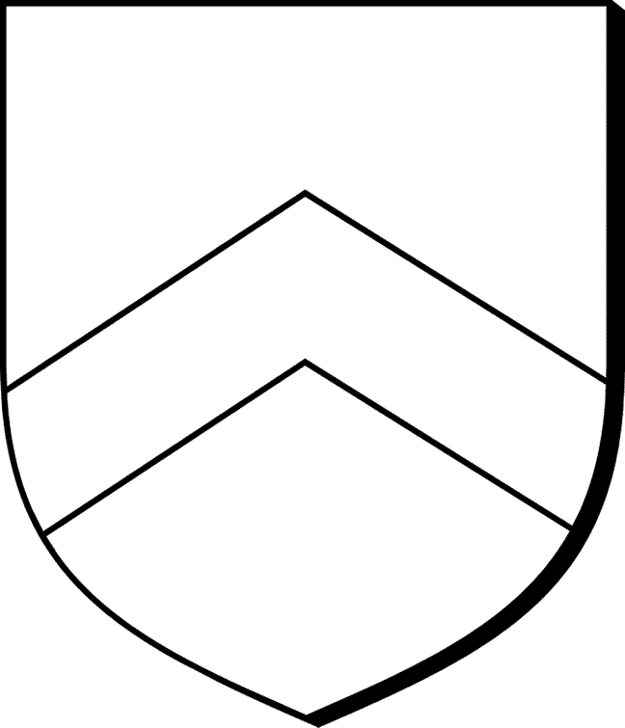

An ermine, as we already know, is a stoat, i.e. small animal. Its winter fur, white with a black-tipped tail, is the fur most frequently used in heraldry. This is what a stoat in winter coat, i.e. an ermine, looks like



In medieval times many ermine skins used to be sewn together to make a blanket producing a pattern of small black spots on a white field. To represent this in heraldry, ermine is shown as a white field strewn with little black tailtips, usually accompanied by three black dots, which represent the fastenings by which the pelts were sewn into clothing. These are known as ermine spots. Here is an example of typical ermine spots in heraldry:

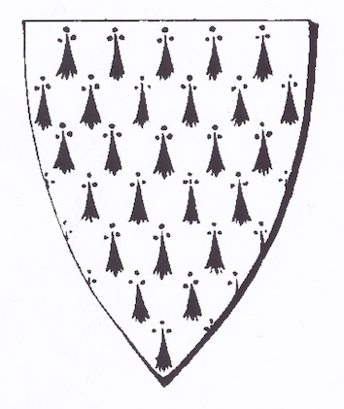

So, Azure, a chevron ermine means the background of the field is blue (azure) and that a chevron filled with ermine fur and spots is placed against this blue background and it is also
between three pheons points upwards argent. In heraldry a pheon is a barbed arrowhead. This is what a pheon looks like:

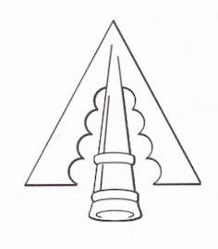

Argent = silver, so we have three silver pheons. On a coat of arms pheons point downwards, unless, like in the original Moodie coat of arms, it is specifically stated that they are pointing upwards. This is where there is a bit of confusion about the later (present) Moodie coat of arms. We'll come to that presently, so let's continue with the description
in chief: A chief is a band running across the top of the shield to cover about a quarter to a third of the shield's surface, or it simply refers to the top quarter or third of the shield or section of the shield
a hunting horn or: Or = gold/yellow. So in the top quarter or third (in chief) a golden hunting horn is placed. When the colour of the chief is not mentioned, it is the same as the main background colour, in this case blue. Very often the chief is red.

So, if an heraldic engraver or designer reads this blazon:

Azure, a chevron ermine between three pheons points upwards argent; in chief, a hunting horn or

he'll design something like this:

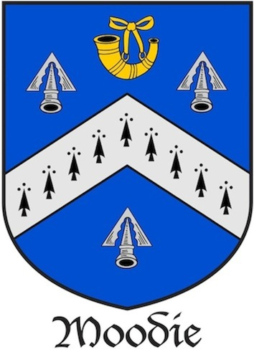

Why I say "something like this", is because the charges, in this case the pheons, ermine spots or hunting horn, may vary slightly from designer to designer, but will still be acceptable within the heraldic community.

Now a bit of background to the later (present) Moodie coat of arms.

In 1707, during the Spanish War of Succession (1701-1711), Captain James Moodie, seventh Laird of Melsetter, was sailing with three ships under his command (hence three ships on the coat of arms) along the east coast of Spain when they discovered by accident that the town of Denia was under siege by a strong force under the Chevalier d'Asfeld of France. Captain Moodie reacted immediately and landed a considerable amount of ammunition for the garrison. He and his men also made a sudden sally at the head of the garrison which caused the enemy to panic and lift the siege.

For these deeds King Charles of Austria recommended to Queen Anne that Captain Moodie be rewarded.

Which she did. She presented him with a richly ornamented Turkish scimitar, a stiletto, and a Field Marshall's baton (see photo opposite p. 38 in The Moodie Book), as well as an Arabian horse. In 1707 she also granted him a coat of augmentation to be borne quarterly, i.e the shiel should be divided into four sections.

Augmentation to a coat of arms was one way of a ruler expressing thanks to someone for a patriotic deed. An augmentation is exactly what it says: the original coat as well as additions thereto. The augmented form of a coat of arms usually resulted in the shield being divided into four ('to be borne quarterly') with the new addition in the first quarter and the fourth quarter and the original moving to the second and third quarters.

The coat of augmentation granted by Queen Anne to Captain Moodie can, of course, only be used by his lineal descendants.

The blazon for the coat of augmentation reads as follows:

Arms quarterly - 1st and 4th azure, three ships in sail argent, on a chief wavy gules, a beacon or; 2nd and 3rd azure, a chevron ermine between three pheons argent; in chief, a hunting horn or.
Crest - On a naval coronet a lion passant regardant, holding in its dexter paw a flag with the double-headed eagle of Austria.
Mottoes - Above the crest, "The Reward of Valour"; below, "God with us".

Again, if a heraldic designer reads this, he'll design something like this:

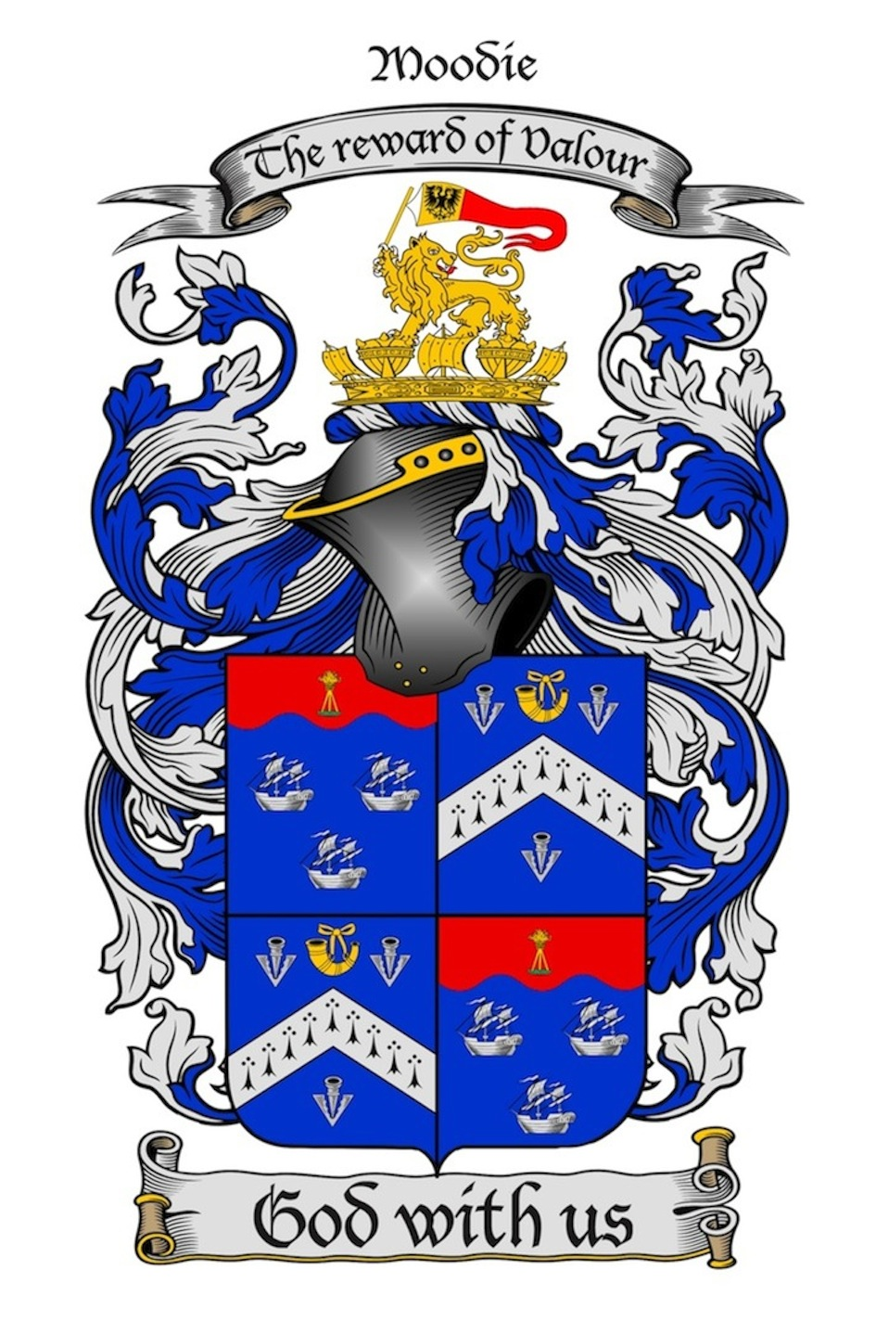

So, let's again try and explain the blazon:

Arms quarterly means that the shield is divided into four parts, i.e. quarters, the 1st is top left, 2nd top right, 3rd botton left and 4th bottom tight
1st and 4th azure. Azure = deep blue. This means that the main backgound of the 1st and 4th quarters is deep blue.
three ships in sail argent Argent = silver. This means that against this blue background there are three silver ships in sail.
on a chief wavy gules. A chief, as stated before, is a band covering the top quarter or third of the shield, or in this case, of the 1st and 4th quarters. Chief wavy means that the bottom dividing line of the chief is wavy. Gules = red. This means that the chief's background colour is red.
on a chief wavy gules, a beacon or. Or = golden/yellow. So, on the red chief a golden beacon is placed. In heraldic terms a beacon is a primitive "lighthouse", i.e. a pyre on top of a tower or stand which can be reached by a ladder and set alight to warn ships. This is an example of an heraldic beacon:
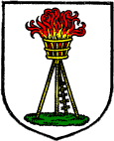
The heraldic engraver who designed the coat of arms of Major James Moodie, ninth of Melsetter (see the frontispiece in The Moodie Book) was a bit over-enthusiatic and turned the beacon into an heraldic tower out of which flames were shooting up.
2nd and 3rd azure, i.e. the background colour is also blue
a chevron ermine. This was explained above, but let's repeat it here. We know a chevron is something like an upside-down V. Chevron ermine means that the chevron's surface is covered with ermine fur.
An ermine, as stated above, is a stoat, i.e. small animal, and its winter fur, i.e. white with a black-tipped tail, is the fur most frequently used in heraldry. Black patterns, known as ermine spots, used to be placed onto the white field on the shield to represent the tail and enrich the white fur.
between three pheons argent. Also, as already explained: a pheon is an arrow-head barbed on the inside. If not stated which way the pheon should point, it points downwards. This is where the uncertainty arises. The blazon for the original Moodie coat of arms states that the pheons point upwards, but there is no such specification in the blazon for the coat of augmentation. One might reason that because it is a coat of augmentation the 2nd and 3rd quarters should be the same as on the original coat of arms. But two heraldic experts agreed that the coat granted by Queen Anne has a full heraldic description (blazon) and should be read on its own, which means that the pheons should point downwards. But they say one can only get complete clarity by consulting the original Letters Patent granted by Queen Anne. And where are they? They might have remained on the Orkney Islands, or they might be in possession of the Moodies in the Cape. Or with Benjamin Moodie's other papers in the Drostdy Museum in Swellendam. When I'm in South Africa again, I'll try and find out. In the meantime I'm following the advice of the heraldic experts and having them pointing dowwards.
So, a chevron ermine between three pheons argent, means that the chevron is situated between the three pheons.
in chief, a hunting horn or. This was explained earlier: a golden hunting horn is placed in the top part (chief) and in the middle of the 2nd and 3rd quarters

Also part of the augmentation are the crest, the mantling and the motto.

Crest A crest is a figure anciently affixed to the helmet of a commander to distinguish him in the confusion of battle.
Let's repeat the crest granted by Queen Anne:
On a naval coronet a lion passant regardant, holding in his dexter paw a flag with the double-headed eagle of Austria.
On a naval coronet. A coronet is a small crown, or a crown borne by those who are not sovereigns; in this case a naval coronet. The colour of the coronet is not stated. I like the golden colour, but it could also be silver.
lion passant regardant. In heraldic terms a lion passant is a lion walking so that it has three paws on the ground and the right front one raised; regardant in heraldic terms means that the lion is looking backwards over its left shoulder.
holding in his dexter paw. In heraldic terms dexter = right and sinister = left.
So, in his right paw the lion holds a flag with the double-headed eagle of Austria. It is also known as the imperial eagle because it used to be borne by German emperors. Although the blazon states a flag, we followed Major James Moodie's bookplate and made it a pennant. Pennants were common on coats of arms in those days. According to the shading on the bookplate, the background to the black eagle is or (gold); the rest of the flag is gules (red)
The crest usually rested on a wreath or torse which in turn rested on the helmet.
The wreath is a twisted band composed of two alternating strips, usually in the two main colours of the coat of arms, or the main colour (in this case blue) and white.
From the helmet drapes the mantle/mantling.
The mantling represents the lambrequin or covering of the helmet to protect it from the sun or rain. The mantling is usually also in the main colour and main metal, in this case blue and silver
Mottoes - Above the crest, "The Reward of Valour"; below, "God with us".

Motto = a word or sentence on a scroll, usually below the shield, but sometimes, especially in Scotland, above the crest. The Moodie coat of arms granted by Queen Anne has one above and one below.

